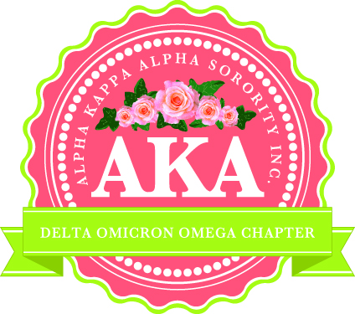

SCHOLARSHIP APPLICATION

Petals of Hope Foundation, Inc is comprised of the members of the Orlando Chapter of Alpha Kappa Alpha Sorority, Inc.
Alpha Kappa Alpha Sorority, Inc. founded in 1908, is the oldest black sorority in the U.S.A.

Personal Data

Name ___________________________ Email Address ___________________________

Date of Birth ________________________ Phone Number ( ) _______________

Current Residence____________________________________________________________
Street City Zip

Name(s) of Parent(s) or Guardian________________________________________________

Number of Siblings Who Reside in the Household _____ Brothers_____ Sisters _____

Educational Data

School Presently Attending_______________________________________________

School Address___________________________________________________________________
Street City Zip

Grade Point Average (Grade 9 through First Semester of the Senior Year) ____________ ___________
Un-Weighted
Weighted

SAT Scores___________ ___________ ACT Score_________
Critical Reading Math
___________ ___________ _________
Date Taken Date Taken Date Taken

College or University Which You Plan to Attend________________________________

Address____________________________________________________________________________________
Street City/State Zip

Counselor’s Name _________________________ Counselor’s Phone # ___________________________

Student Activity Information

Directions: Please complete each section. DO NOT BE MODEST. All information can be used by the Scholarship Committee during the selection process.

Extra-Curricular Activity | Description | Leadership Position Held | Length of Service

Community Activities

Directions: List community activities in which you have participated, (Church groups, volunteer organizations, clubs, community art endeavors, etc.). The activities in which you engage must be completed outside of school.
Community Service Activity | Description | Length of Service

Work Experience

Place of Employment | Description of Responsibilities | Dates

Recognition & Awards

Directions: List any honors and recognition that you have received (Grades 9 - 12).

Award/Recognition | Grade(s)

References

Directions: Two letters of reference are required. One must come from a teacher, and one must come from a church member, community member, or an employer. References from relatives will not be considered. Letters of reference should address the following:

Character
Personality
Motivation
Initiative
Sense of Responsibility
Citizenship

Application and requested documents must be received by Friday, March 1, 2019. The application and all required information must come in one packet, first class U.S. mail (please no certified mail return receipt request). Information received after March 1, 2019 will disqualify the applicant.

Direct applications and letters of reference to: Alpha Kappa Alpha Sorority, Inc.
Orlando Chapter
Attention: Dr. Felecia Boyd
P.O. Box 555036
Orlando, FL 32855

